

**Addis Ababa University**

**Addis Ababa Institute of Technology**

**School of Electrical and Computer Engineering**

**Game Design Document (GDD)**

**For**

**Adwa Game**

Date of Submission: - December 3, 2015

Table of Contents

Introduction 5

Game Engine and Structure 6

 6

**Pros** 6

• Easy to use and compatible with every game platform. 6

• Great community support. 6

• Low learning curve. 6

Cons 6

• Time-consuming for making games with complex and diverse effects. 6

 7

Pros 7

• With so many developers using it, Unreal offers the largest community support. Several lifetime hours of video tutorials and assets are available 7

• There is widest range of easy to maneuver tools up under its sleeve. There are few tools that can be maneuvered even by a school kid. 7

• Compatible with diverse operating platforms including iOS, Android, Linux, Mac, Windows, and most game consoles. 7

Cons 7

• Some developers complain a lot about the unfriendly tools that involve a bit of a higher learning curve. 7

 7

**Pros** 7

• The game engine also offers the easiest Al coding of any tech on the market. 7

• Cry Engine 3 makes the game ambience pretty with its artist-level programming capability in its Flow graph tool. 7

• For a beginning developer, UI scale form comes handy. 7

Cons 7

• Being relatively new to the industry, the engine is yet to find a robust community 7

• Learning curve is pretty challenging for a starter 7

 8

Pros 8

• It offers several open-world maps and lively instances. It also offers a seamless transition between them. Offers fairly robust A.I.s. 8

• Easy and handy mapping tools and integrated tool set. 8

• The scripting is powerful enough to help you develop complex missions, crafting, and gathering resources. 8

Cons 8

• Scripting engine is powerful but no intuitive. 8

• HeroEngine together with HeroCloud is expensive for a new developer or startups. 8

• Higher learning curve for a new developer. 8

Looking at these all game engine s we finally choose Unity3D since the unity3D game engine has low learning curve and there is wider community base on unity compared to other game engines. 8

Top-Level Components of Adwa 3D Game 8

The Game Engine 9

Unity3D Engine offer reusable components that can be manipulated to bring a game to life. Loading, displaying, and animating models, collision detection between objects, physics, input, graphical user interfaces, and even portions of a game's artificial intelligence can all be components that make up the engine. In contrast, the content of the game, specific models and textures, the *meaning* behind object collisions and input, and the way objects interact with the world, are the components that make the actual game. 9

Game Objects 9

The Simulation 10

The Data Manager 11

Why Unity3D? 11

Version Controller 12

Graphics Elements 12

Physics Components 12

Scripting Tools 13

User Interfaces 13

Game development procedures (Steps) 14

1. Game description 18

1.1 Design Goal 21

2. Game mechanics 25

2.1 CORE GAME PLAY 25

2.2 Game Flow Diagram 29

2.3 Game physics and statistics 36

3. Architectural Design 39

3.1 Graphical representation and Description 39

3.2 Interaction between views 58

4. HIGH LEVEL AND DETAILED DESIGN 62

4.1 LOGIC FUNCTIONS 62

# Introduction

In order to make the game design and coding stage of Adwa simpler the whole game project was divided into 7 levels during the SRS preparation period. This partitioning of the game is applied when it comes to the preparation of Game design document. These levels have a very minimal level of interaction (cohesion) which implies that the levels can easily be developed independently.

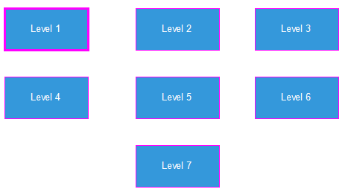

Figure : the partitions of the game

The interaction among the different level is plotted in fig 2.The interaction is based on the player’s promotion passing through the different levels. The player is going to be upgraded, when it passes the levels, by different kinds of weapons.

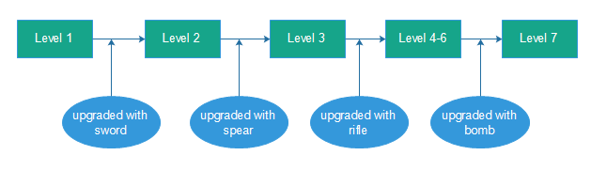

Figure : interaction between levels

To make the implementation and coding part simpler each level is first described and then further divided into different sub – modules as described in figure 3. The description part describes what the given level is all about. Game flow diagram is used in order to further illustrate the game description part. After the description the level is sub-divided into different loosely related sub-modules and then the sub-modules are explained in detail. Finally the pseudo-code for the sub-modules is designed.

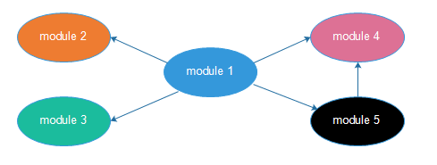

Figure : a level divided in different modules

# Game Engine and Structure

There are different kinds of 3D game engines out there. Looking at various aspects including the pros and cons of these game engines, we finally decided to choose Unity3D game engine for developing this Adwa 3D interactive game. To mention some of the game engines we were looking at pros and cons of different kinds of game engines



**Pros**

* Easy to use and compatible with every game platform.
* Great community support.
* Low learning curve.

Cons

* Time-consuming for making games with complex and diverse effects.



Pros

* With so many developers using it, Unreal offers the largest community support. Several lifetime hours of video tutorials and assets are available
* There is widest range of easy to maneuver tools up under its sleeve. There are few tools that can be maneuvered even by a school kid.
* Compatible with diverse operating platforms including iOS, Android, Linux, Mac, Windows, and most game consoles.

Cons

* Some developers complain a lot about the unfriendly tools that involve a bit of a higher learning curve.



**Pros**

* The game engine also offers the easiest Al coding of any tech on the market.
* Cry Engine 3 makes the game ambience pretty with its artist-level programming capability in its Flow graph tool.
* For a beginning developer, UI scale form comes handy.

Cons

* Being relatively new to the industry, the engine is yet to find a robust community
* Learning curve is pretty challenging for a starter



Pros

* It offers several open-world maps and lively instances. It also offers a seamless transition between them.  
  Offers fairly robust A.I.s.
* Easy and handy mapping tools and integrated tool set.
* The scripting is powerful enough to help you develop complex missions, crafting, and gathering resources.

Cons

* Scripting engine is powerful but no intuitive.
* HeroEngine together with HeroCloud is expensive for a new developer or startups.
* Higher learning curve for a new developer.

Looking at these all game engine s we finally choose Unity3D since the unity3D game engine has low learning curve and there is wider community base on unity compared to other game engines.

## Top-Level Components of Adwa 3D Game

The Adwa game is organized in levels that correspond to the different stages and roles. The player progresses in the game by accumulating experience and points in return for accomplishing simple tasks. Each role has its own objectives and tasks.

Adwa 3D game architecture has the high-level structure as shown in Figure below. The functional components of Adwa 3D interactive gaming are, **The Game Engine, The Simulation, Game Object System**  and **The Data Manager**.

**Simulation Controller**

**Object System**

**Data Manager**

## The Game Engine

Unity3D Engine offer reusable components that can be manipulated to bring a game to life. Loading, displaying, and animating models, collision detection between objects, physics, input, graphical user interfaces, and even portions of a game's artificial intelligence can all be components that make up the engine. In contrast, the content of the game, specific models and textures, the meaning behind object collisions and input, and the way objects interact with the world, are the components that make the actual game.

The game engine is responsible for interacting with the player, through the computer hardware and operating system. In most cases, the game engine can be designed and developed as generic software for a particular game genre.

The primary modules in the game engine are **Graphics**, **Audio**, **OS interface** and the like

Graphics



**Game Object**

Audio

Interfaces

Game Objects

Game Engine

Computer

Player

One characteristic of the game engine modules is that their functional decomposition is natural and there is little or none coupling between them. In addition, these modules have very little internal state and the data flow through them is uni-directional.

While the internal structure and algorithmic design of these modules is non-trivial, they are better understood and documented than many other components in game software.

## Game Objects

Game objects represent the actors of the game world. A game object can be either static or dynamic. Static game objects do not react to external stimuli and therefore, do not interact with the world or other game objects. They are often scenery elements, like a tree or a rock. Dynamic game objects, on the other hand, can interact with other game objects.

The object system is responsible for maintaining the state information describing all objects in the game world. This system resides in memory for real-time access to all game state information.

Camera Component

Drawable

Audio Component

**Game Object**

Video Component

## The Simulation

The simulation is the heart of the game itself. This component realizes the virtual world of the game and maintains the rules of the game. The simulation control module receives player input information from the game engine and passes it to **The Player AI**, **The Enemies AI**, **The Bot AI module**, **The Game Logic** or to **The Physics.**

Player AI

**Simulation Controller**

**Game Object**

Physics

Game Logic

Bot AI

Enemies AI

The physics module is concerned with the interaction of objects in the virtual world according to the physical properties of that world. The AI module is concerned with the internal thought and decision process within (virtually) animate objects. Finally, the game logic module handles those issues that are not specifically part of the virtual world in which the game is played, but are rather computations and constraints inferred from the rules of the game. These modules do not interact directly; rather they interact through the information that describes the state of the objects in the game world that is stored in the object system. In our discussions, we found it useful to think of the interaction between AI and physics as follows. AI generates impulses based on the internal state of animate objects. For example, the AI for an object might generate an impulse to move towards water or to swing a fist. Physics turns impulses into actions and ensures that the results of those actions do not violate the physical laws of the virtual world.

## The Data Manager

The data manager is responsible for retrieving game data from the file system or some other persistent storage and for managing storage and retrieval of game state for save/load game functionality.

The object system is responsible for maintaining the state information describing all objects in the game world. This system resides in memory for real-time access to all game state information.

## Why Unity3D?

Unity3D game engine has many diversified components which make it easy to make any interactive game in less effort and high quality. Among those different kinds of components that the unity system provides, here are some of the components that we are going to use to develop the Adwa 3D interactive game.

Collider

Cloth

Character Joint

Constant Forces

Character Controller

Lighting

Terrain

Camera

**Graphics Elements**

**Scripting Tools**

**Physics Components**

**Version Controller**

**User Interface Systems**

Canvas Components

Event System

Visual Components

Time & Frame rate mng

Sprite

Interaction Components

Control Game Objects

## Version Controller

Using a **version control system** makes it easier for a user or multiple users to manage their code. It is a repository of files with monitored access, which in the case of Unity, will be all the files associated with a Unity project. With version control it is possible to follow every change to the source along with information on who made the change, why they made it and what they changed/added. This makes it easy to revert back to an earlier version of the code or to compare differences in versions. It also becomes easier to locate when a bug first occurred along with what code might have caused it.

## Graphics Elements

* **Camera**

A camera is an object that defines a view in scene space. The object’s position defines the viewpoint, while the forward (Z) and upward (Y) axes of the object define the view direction and the top of the screen, respectively. The Camera component also defines the size and shape of the region that falls within the view. With these parameters set up, the camera can display what it currently “sees” to the screen. As the camera object moves and rotates, the displayed view will also move and rotate accordingly.

* **Lightning**

This tool is used to calculate the shading of a 3D objects in the game. There are many advanced lighting features available in Unity, which are intended to help in creating a better

* **Terrain**

Unity’s Terrain system allows adding vast landscapes to game. At runtime, terrain rendering is highly optimized for rendering efficiency; a selection of tools is available to make terrains easy and quick to create. This section explains the various options available for terrains and how to make use of them.

* **Sprite**

Sprite is a two-dimensional image or animation that is integrated into a larger scene.

## Physics Components

* **Colliders**

Collider components define the shape of an object for the purposes of physical collisions. A collider, which is invisible, need not be the exact same shape as the object’s mesh and in fact, a rough approximation is often more efficient and indistinguishable in game play.

* **Character Joint**

It is used to attach one rigid body object to another or to a fixed point in space using a Joint component. Generally, a joint to allow at least some freedom of motion and so Unity provides different Joint components that enforce different restrictions. For example, a Hinge Joint allows rotation around a specific point and axis while a Spring Joint keeps the objects apart but lets the distance between them stretch slightly.

* **Cloth**

The Cloth component provides a physics-based solution for the simulation of fabrics and works in conjunction with the Skinned Mesh Renderer. While it has been specifically designed for character clothing it is still possible to use arbitrary, non-skinned meshes.

* **Character Controller**

The Character Controller is mainly used for third-person or first-person player control that does not make use of Rigid body physics.

* **Constant Forces**

Constant Force is a quick utility for adding constant forces to a Rigid body

## Scripting Tools

* **Event System**

The Event System is a way of sending events to objects in the application based on input, be it keyboard, mouse, touch, or custom input. The Event System consists of a few components that work together to send events.

* **Time and Frame rate manager**
* **Control Game objects**

This tool helps a lot in controlling the game objects in the scenes using the game object components

## User Interfaces

* **Canvas Components**

The Canvas component represents the abstract space in which the UI is laid out and rendered. All UI elements must be children of a Game Object that has a Canvas component attached.

* **Visual Components**
  + **Text**

The **Text** component, which is also known as a Label, has a Text area for entering the text that will be displayed. It is possible to set the font, font style, font size and whether or not the text has rich text capability.

* + **Image**

An Image has a Rectangular Transform component and an **Image** component. A sprite can be applied to the Image component under the Target Graphic field, and its color can be set in the Color field. A material can also be applied to the Image component.

* + **Mask**

A Mask is not a visible UI control but rather a way to modify the appearance of a control’s child elements. The mask restricts the child elements to the shape of the parent. So, if the child is larger than the parent then only the part of the child that fits within the parent will be visible.

* + **Effects**

Visual components can also have various simple effects applied, such as a simple drop shadow or outline. See the Effects reference page for more information.

* **Interaction Components**

Interaction Components handles interaction, such as mouse or touch events and interaction using a keyboard or controller.

# Game development procedures (Steps)

How does the overall game development progress? To answer this question, we have chosen a listed approach to the overall game implementation life cycle. This listed approach divides the cycle in to nine stages. Each stage is discussed in detail below:

1. **Scene (Environment) setup:** this stage mainly involves creating a realistic game area (environment) where the game characters can interact with each other. The environment will mimic the real world in the way that things and characters interact.Natural elements like physics are partially implemented at this stage.

The game scene (Environment) will hold different game objects, interactive and non-interactive. These game objects will create the feel-and-touch of the game. Trees, bushes, walls and other non-interactive game objects will help create a realistic scenery in the game play while colliders prevent the player from going through them. Texture meshes will also give these objects texture. Hills, plateaus and gorges will also be created in the game scenery to mimic a realistic landscape of a war arena.

The game scene is natively created in unity studio using different assets from the unity asset store. These assets have a pre-built texture mesh so they enable the game developers to deploy different game objects with ease. At this level of game implementation phase, we will not be importing any custom made game objects in to the scene.

1. **Character creation and controller setup:**  at this stage of the game implementation, we will incorporate the player and other figure characters in to the game by importing the mesh designs of these characters from blender. A detailed animations of these characters will then be constructed using key framing and other techniques. Controller scripts will also be incorporated in to these game objects to enable the player control the main character to perform different tasks.

3D Character meshes of different figures in the game will be developed in blender. These meshes will have a reasonably low resolution to create a minimum graphics objects.Based on the characters identity, different hinges will be embedded in this meshes to create animations for the characters in unity.

These game objects will be imported in to unity to create different characters. These objects will then be linked with their own scripts for different features like sound, movements and controls. Based on the identity of the characters, the complexity of these scripts will vary depending on the role it play in the arena. The main character will have the scripts with highest complexity. These scripts will control different features of the player like its health, motion, weapons, collision, sound effects and other details.

1. **Weapon creation and implementation:** this stage involves importing the mesh designs of different weapons and tools from blender in to the game development environment, unity. Controller scripts will also be developed to enable the player use these weapons.

Swords, spears, shot guns and other tools of the game play will be designed in blender with minimum complexity in mesh structure. These meshes will enable us to create a minimum graphics items with ease. These tools will then be imported to the unity environment to create game objects. These game objects will be linked to their own separate scripts for differentfeatures like sound effect, controls and animations.

1. **Enemy bots setup:** this stage covers a very vast section of the game implementation phase. Enemy troops of various ranks will be programmed in to the game to perform different tasks. These bots can be interacted with during the game play but the player has no control over them.

At this level of the game implementation phase, much portion of the game logic will be implemented to create patterns of challenges for the player. This will enable us to create an entertaining and engaging game while taking the player down the story line of the historic battle of Adewa. Mesh structures of enemy bots of different ranks will be created in blender imported to unity. These bots will then be linked to their own copy of scripts for different object features like animation, combat, sound and collision. Most of these bots will run their own copy of a main script.

1. **Player tools:** this stage involves developing special tools the player may use during the game play. These tools include a map, health bar, hint display and aim (shooting target). These tools are designed to assist the player during the game play to achieve different goals easily.

In game tools provide the player different information like level of health (how much hits the player has taken from enemy bots), location and direction of movement, score, and other information like mission objectives. These tools will be 2D objects in the game scene environment with fixed positions in the game play window.

2D images of these tools will be first developed in Adobe photo shop and will then be imported in to unity. These images will then be linked to their own separate controller scripts. These scripts make sure the tools provide a useful and reliable information to the player.

1. **Game manager and in game GUI:** this stage of the game development involves developing a game manager system that oversees the game loop. It controls the general flow of the level story. It oversees the achievements of the player and decides the start and completion of the stage. It progresses the player to the next level or starts the level again if the player has failed the mission.

In game GUIs include pause, resume, mute and unmute mechanisms in the game play window.

These features can also be accessed through keyboard buttons

1. **Animations and narrations:** at this stage of the game play, we incorporate different animations and motion graphics works in to the game to create a better narration to the game story. These animations and motion graphics videos will be inserted in various points of the game story to provide the player with a better story continuity.
2. **Special effects and other objects:** In this stage of the implementation phase, we incorporate different game objects in to the game environment to improve the game interactivity and attractiveness. These game objects vary in purpose and logic but are all important to create a better game play experience for the user. These objects include healing boxes, …
3. **General game manager:**this level is the final phase of game implementation process. It involves developing the Graphical user interface (GUI) for accessing different levels of the game. It includes resume, start new, quit options for resuming, starting new game and quitting the game.

Even though the game implementation phase is described sequentially, most of the stages discussed can be performed in parallel. Thus, at any given time during the implementation, different teams will be working on different stages of the phase paving roads for the teams working on the subsequent stages.

The overall process of the game development can be summarized with the image below

. . . . .

Special effects and other objects

Animations and narrations

Game manager and in game GUI

Player tools

Enemy bots setup

Weapon creation and implementationsetup

Weapon creation and implementationsetup

Character creation and controller setup

Create scenes

**General game manager**

Special effects and other objects

Animations and narrations

Game manager and in game GUI

Weapon creation and implementationsetup

Player tools

Enemy bots setup

Weapon creation and implementationsetup

Character creation and controller setup

Create scenes

# Game description

**Level 1:**

* The overall game`s purpose is entertain and teach the interactive player about history
* Specifically this level one is aimed to express the event that happened in the place called Halai and a character has been created for fictional purpose due to inconsistent win over our enemy for the interactive player to progress through the game until the end.
* Interactive player start the game after listing to the narrated video about the war between Major Toselli and Bahtahagos also over all history of Adwa and this narration was needed to show the history relevance behind game.
* the first event to happen is the fictional character finding a letter from wounded man and by this scene we tried to show what was the convince way to transmit massage at that time, even though the Italians and Ethiopian’s used to communicate using a telegram the Ethiopian rebels don`t have that privilege and we tried to show what kind of typography were used at the time.

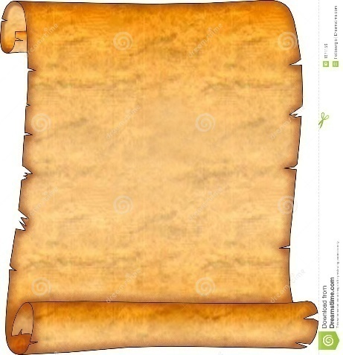after reading the message the player start his journey to Halai. At this moment a map would appear on the screen and our interactive player should properly read the map`s instruction, at this point our aim is to engage our player to be familiar with those basic components and move forward in the game

Figure : "Berana"

* the next step would be reading the map and moving to the lake kurma at these point the aim of the game focus is more on showing you what the environment would looking like which is very drastic place and the task where the player had to drinking water is to create a challenge to move forward in the game.
* the last task would be finding Bahtahagos and this point the history relevance comes in play again to show that we lost the first rebellion attack against our enemy though our player had to move on to the next level so that the fictional character we created would get this token from bahta at his last moment and finish the level

**Level 2:**

The game on this level is based on the battle of Coatit, which was between the Italians, led by Baratieri, and Ethiopian proxies led by Tigrian warlord Ras Mengesha Yohannes in what is now present day Eritrea. Weeks after crushing Okule´-Kusai rebellion in northern Ethiopia at Halai, Italian General Oreste Baratieri turned against rebel leader Ras Mengesha of Tigre. The Italians and native askaris attacked Ras Mengesha northeast of Adowa at Coatit, where badly armed Tigreans fought a brave draw, then withdrew.

**Level 3:**

The game on this level is based on the battle of AmbaAlagi, which was fought between the Italian General Baratieri and Ethiopia's Emperor Menelik during the First Italo-Ethiopian War. This battle led to the annihilation of the Italians and the death of major Toselli.in 1895, RasMengesha set out to do battle with the Italians, as portrayed on level 2, and was made to retreat from Coatit. Fired by their success the Italians pushed on to the south, and at length found themselves in Adigrat, Mekelle and AmbaAlagi, which they fortified. Being unused to warfare in mountainous districts, five companies of the Italians under Major Toselli were cut up by the Abyssinians at AmbaAlagi. The Italians lost 2500 men and 130 officers and major Toselli also died.

With accountability to the history of battle of AmbaAlagi in mind, the player who progressed from level 2,will be notified of the objective, which is to kill Major Toselli. The player will find himself in RasMengesha’s team attacking Major Toselli’s soldiers. The design of the environment will try to be true the actual battle field of AmbaAlagi.

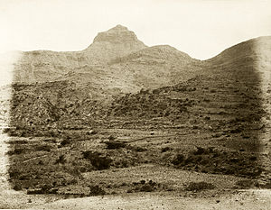

Figure : "Amba Alagi"

**Level 4:**

The game at this level is based on the battle between Albertone’s brigade and Ethiopian’s that were waiting behind a mountain. Albertone’s soldiers fought for 2 hours until Albertone’s capture. So without losing the history we tried to come up with this game description. The main player will be at the mountain with his artillery and the enemies will come at him in pairs or three. Then the main player has to kill the first eighteen Albertone’s soldiers. After successfully killing these eighteen soldiers two soldiers will come at him with Albertone and he/she has to kill them and surrender Albertone without injuring him.

**Level 5:**

The game in this level is based on the fight between the Arimondi Birgade, that the fleeing Albertone soldiers sought refuge at, and the Ethiopian mountain artillery soldiers that are later joined by the 25,000 Shewans from Minilik.

**Level 6:**

**DABORIMIDA VS THE OROMO CAVALRY**

This is level of Adwa game mainly focuses on the history of the battle between Ethiopian Oromo cavalry under the command of Ras Mikael versus the Italian army under the command of Vittorio Daborimida.

At the time of the battle, Dabormida's Italian brigade had moved to support Albertone but was unable to reach him in time. In the meantime, Minilik became informed of the Dabormida’s position. Minilik ordered Ras Mikael and the entire left wing of 20,000 warriors supported by 8000 cavalry to move on and destroy it before it escape. Sensing the enemy was to collapse, Ras Mikael ordered 8000 cavalry to charge. So the Ethiopian soldiers slash down the Italian’s and herd them into defenseless pocket.

We tried to pass this great history to the next generation through this game level. We tried not to leave any history behind on this level of the game.

**Level 7:**

The game starts with the command of Nigus Teklehaimanot of Gojjam and some wounded warriors of Ethiopia. The king will tell his soldiers that the Gojjam people are brave as every Ethiopian are and orders to fight for their country .His message is as follows…

“እኛ ጎጃሜዎች ሁሌ ተከብረን ነው የኖርን:: ማንም ጠላት ደፍሮን አያውቅም፣አይደፍረንምም አሁንም ጦጵያን በጀግንነታችን አናሳፍራትም የሀገሬ ሰው ታጥቀህ ተነሳ !!! ”

The wounded soldiers will also make a speech for the peoples gathered not to forgive the Italians rather to chaise, surrender and invade them until the end of the war. They also tell the soldiers that they are wounded and prefer to die for their country as it is a pride for them.

During this time the whole sword will make a crowd voice and start “shelella” and “Kererto” and after 5 seconds later by the order of the king the soldiers will start to move to fight and defend the country into the battle.

The camera perspective will move to tents where the player is arrested and tortured. In the tent there are two Italian troops and the player. The player since he is tortured, his blood is seen on the ground, being his face bloody, his eyes injured, his head is kept down, his hands are arrested in the backward with the chair. When the Italians hear the echo of the crowd of the Ethiopian soldiers, they turn their heads to the source of the sound and one of them will get out of the tent and checks. After a while he comes back and tell the other guard that it is the Ethiopian soldiers and they get out to send telegram message to Barraiteri .This time the player will start to investigate his rooms and finally has to notice the sharpy iron on the table near by. He then uses his right and left keyboard arrows to move his tables and finally get the sharpy iron. Finally he has to unlock his hand and has to hide to attack the Italian guards using this sharpy iron. If this is successful, he should take their weapon for his mission, otherwise the next step will be very challenging. This ends Checkpoint-1 and Checkpoint-2

After this the player should move out of the tent for his next mission. As he gets out there will be 5 Italian soldiers around “mount Belah” hiding. The player should kill them as fast as possible otherwise he will be attacked. If successful the game continues. On his way to tent to for invading the Italians he should get into the armament store for a bomb for his next Checkpoint to be successful, other wise he will easily be attacked and die. When he approaches the next Checkpoint he should throw the bomb and destroy the camp before the 10 Italians discover him. If successful he will continue to the next stage. This ends Checkpoint-3.

The last checkpoint will be the soldiers dinning camp, where soldiers gather to eat for lunch and dinner. The player must be inside the army to attack the large group of soldiers for this purpose he should dress like the Italian soldiers. In order to do this he has to either go back and change his clothe from the dead Italians soldiers or will be attacked easily. Changing the cloth will be done using the “Enter” keyboard key once approached the dead Italian from 0.5meter. The toxic object is given to him around 100 meters from the camp and using an arrow to show exactly where it is.

The dining room will have wooden chairs, and around 20 soldiers.

After getting into the dinning camp slowly he should enter into the kitchen and use the some toxics to contaminate their food. If successful he could kill all the soldiers there and accomplishes the last session, checkpoint-4.After this the player will go back to celebrate his victory with his compatriots, with a military position award!

## 1.1 Design Goal

**Level 1:**

The game has two main inputs

**1.** Design or graphic input

* Creating the main character

(Doing this will include considering what he should looks like regarding physical appearance, hair style clothing and soon….)

* Try to imitate the historic event participants like Bahtahagos in the narration

(Since there is a photo of Bahtahagos the task would be creating the character resembling what how he should look like)

* Designing what the environment would look like
  + What the color intensity should look like
  + How the wind should sound
* Pictures of head model ,hair style and clothing

**2.** Logical input

* Gathering all the design from the design team

(Incorporating the design teams input to the game structure)

* Creating sequential order for the game script
* Managing the players restricted move

(Since the player is moving in the prescript path and making the moves with a few choice everything is coded accordingly)

**Narration video:**

There are two narrations in level one

1. The first is the fact the player find a wounded soldier on the road and get the letter from him

* When he approach the wounded soldier the game starts the narration and the letter will be shown at the same time it`s narrated.

2. The second narration begins when the fictional character finds Bahta Hagos lying down at his last breath

* A picture of Bahta will laying down taking to the fictional solider and telling him to take the sword as a token to Ras Mengesha

**Level 2:**

The design of this level aims to achieve the following goals.

1. To enable the player be part of one of the first Italo-Ethiopian wars.

2. Serve as a continuity to Level 3, which our player finds Ras Mengesha and follows a map to Ras Welle.

3. Develop an achievement system that rewards the player with spear.

4. Develop a level that keeps its accountability to the actual History while still providing entertainment.

5. Have art and design that is in sync with the landscape of that time.

**Level 3:**

The design of this level aims to achieve the following goals.

1. To enable the player to fight along Ras Mengesha’s army.
2. The player will be able to use his/her sword.
3. Will serve as a continuation from level 2.
4. Will be able to achieve a reward, riffle.
5. Experience a storyline which is accountable to the actual history.

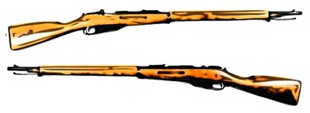

Figure :Prototype of a riffle

**Level 4:**

1. Introduce Albertone’s brigade and Ethiopian’s with their mountain artillery
2. Give the player a reward for his progress
3. Try not to lose the history of the game(Like not killing Albertone)
4. Develop a landscape that is somehow similar to the place that really happened at that time.

**Level 5:**

The design of this level aims to achieve the following goals.

1. Introduce Arimondi and the Shewan forces of Minilik.

2. Serve as a continuity to Level 4, which our player chases to Arimondi's location.

3. Develop an achievement system that rewards the player with ****

4. Develop a level that keeps its accountability to the actual History while still providing entertainment.

5. Have art and design that is in sync with the previous level as they contain the same landscape settings

**Level 6:**

We are going to have a player who passes the past five levels. We are going to have three alternative flows.

1. Flow one

The player will get notified on the objective then the player will find himself in front of Dabormida’s army. The player will starts shooting .if the player kills 30 soldiers and heavily wound Daborimida ,the player will the player will get the privilege of proceeding to the next level.

2. Flow two

The player will get notified of the objective then the player finds himself in front of Dabormida’s army. The player will start shooting but fail to kill 30 soldiers. So the player will get setbacks to the beginning of the level.

3. Flow three

The player will get notified of the objective then the player finds himself in front of Dabormida’s army. The player will start shooting and kill 30 soldiers but fail to wound Daborimida. As a result the player will get set back to the previous check point that is achieved after killing 30 soldiers.

**Level 7:**

1. Creating a tied up condition for the player, because he starts being handcuffed.
2. The player will unlock his hand from the handcuffs.
3. After noticing a sharpy iron on a table he will grab and go out from the tent where he was held hostage.
4. Without being noticed he has to kill the five Italian soldiers around Mount Belah.
5. After killing the five soldiers he will locate the armament tent and grab a bomb
6. In general creating a location around Mount Belah and a camp base for the Italian station will be the main design goal of this level.

# Game mechanics

## 2.1 CORE GAME PLAY

**Level 1:**

* Player finds a wounded soldier with a message and reads it.
* Player decides to go to Halai (Bahtahagos’s location).Player knows Bahta's location from the map popping in a corner.
* Player gets to water.
* Health deterioration (Player's health deteriorates due to the weather).
* Animations (in the beginning middle and end of the game).

Checkpoints

1. Getting message from wounded soldier.

2. Getting to the water source.

3. Finding Déjà mach Bahtahagos.

HOW THE PLAYER PLAYS THE GAME:

This is the first level of the game; in this level the player plays the game using basic controls and some interaction controls mentioned below.

* Action key to perform reading. (Player finds a wounded soldier with a message and reads it.)
* Movement control to navigate through the map. (Player decides to go to Halai (Bahtahagos location).Player knows Bahta's location from map popping in a corner.)
* Action key to drink water. (Player gets to water.)
* Action key to receive sword.( can also be animated)

**Level 2:**

The player in this stage is supposed to save Ras Mengesha, in which throughout the game he will have some obstacles.

First when the player passes to this level he will receive an objective which is to save Ras Mengesha and help him fled from senafe .The player will get to Ras Mengesha location with the help of map, which will pop at the corner. Enemies appear along the way as the player tries to save Ras Mengesha and the player must defeat them.

Up on finding Ras Mengesha after defeating the low abilities soldiers, the player will come with 5 consecutive soldiers of low abilities which will be met individually. After killing each soldier, the map will lead the player and Ras Mengesha to Ras Welle location. Accompanying Ras Welle is the famous leader from Harar, Ras Mekonen.

This level will be completed as the player gets Ras Mengesha to safe grounds. The player will be awarded with spear.

**Level 3:**

**HAPPENINGS IN THIS LEVEL**

* Player gets notified of the objective.
* Player finds themselves in the mid of war, along with Ras Mengesha.
* Player encounters five lowly able soldiers in a consecutive fashion.
* Player kills all five consecutively.
* Player then meets with the two highly trained soldier, one at a time.
* Player kills both consecutively.
* Player gets to Major Toselli.
* Player kills Toselli.
* Player is congratulated for success.
* Player is rewarded with a rifle. Health deterioration
* Animations (in the beginning middle and end of the game).

**HOW THE PLAYER PLAYS THE GAME**

This is the third level of the game; in this level the player hasa to support RasMengesha and kill Major Toselli. To pass this level the player has the following performance abilities

* Action key to swing sword won on level 1.
* Action key to throw spear won on level 2.
* Movement control to navigate through the map.
* Action key to take rifle from Major Toselli.

**Level 5:**

**Happenings in this level**

* Player gets notified of objective for this specific level.
* Player fights with Arimondi's soldiers.
* Positional and camera change following the fleeing of Albertone soldiers.
* Player kills all the soldiers coming their way.
* The player needs to stay alive until Menelik released his reserve of 25,000 [Shewans](https://en.wikipedia.org/wiki/Shewa) and swamped the Italian defenders.
* A war against Arimondi's brigade vs. the Shewans led by Minilik.

**HOW THE PLAYER PLAYS THE GAME**

This is the fifth level of the game; in this level the player plays the game using various game play controls and interaction controls mentioned below

* Movement control to move around while attacking or defending.
* Sprinting control if a player needs to run.
* Attacking and defending whenever player is near enemy.
* Action key to switch between weapons if a player gets another weapon (if a player killed an enemy and acquire the weapon).
* Jump using jumping control if a player needs to jump while attacking and defending.
* Use a defending shield to protect from an enemy attack.
* Crouch using crouching control if a player needs to crouch while attacking and defending.

**Level 7:**

This is the final stage of the battle of Adwa. At this stage the complexity of the game has to increase. The reality is that most of the troops from Italy side are injured and surrendered and no much effort is expected to play against the Italians than level 6. we tradeoff between these and decided to include both in a customized way, how?

**Environment:**

The landscape of “Mount Belah” is full of up and downs. During the war there is a rain and there also were tents around the mountain

**Introduction**

The game starts with the command of Negus Tekele Hayemanot of Gojjam and some wounded warriors of Ethiopia. The king will tell his soldiers that the Gojjam people are brave as every Ethiopian are and orders to fight for their country .His message is as follows…

“እኛ ጎጃሜዎች ሁሌ ተከብረን ነው የኖርን:: ማንም ጠላት ደፍሮን አያውቅም፣አይደፍረንምም አሁንም ጦጵያን በጀግንነታችን አናሳፍራትም የሀገሬ ሰው ታጥቀህ ተነሳ !!! ”

The wounded soldiers will also make a speech for the peoples gathered not to forgive the Italians rather to chaise, surrender and invade them until the end of the war. They also tell the soldiers that they are wounded and prefer to die for their country as it is a pride for them.

During this time the whole sword will make a crowd voice and start “shelella” and “Kererto” and after 5 seconds later by the order of the king the soldiers will start to move to fight and defend the country into the battle.

The camera perspective will move to tents where the player is arrested and tortured. In the tent there are two Italian troops and the player. The player since he is tortured, his blood is seen on the ground, being his face bloody, his eyes injured, his head is kept down, his hands are arrested in the backward with the chair. When the Italians hear the echo of the crowd of the Ethiopian soldiers, they turn their heads to the source of the sound and one of them will get out of the tent and checks. After a while he comes back and tell the other guard that it is the Ethiopian soldiers and they get out to send telegram message to Baratieri .This time the player will start to investigate his rooms and finally has to notice the sharpy iron on the table nearby. He then uses his right and left keyboard arrows to move his tables and finally get the sharpy iron. Finally he has to unlock his hand and has to hide to attack the Italian guards using this sharpy iron. If this is successful, he should take their weapon for his mission, otherwise the next step will be very challenging. This ends Checkpoint-1 and Checkpoint-2

After this the player should move out of the tent for his next mission. As he gets out there will be 5 Italian soldiers around “mount Belah” hiding. The player should kill them as fast as possible otherwise he will be attacked. If successful the game continues. On his way to tent to for invading the Italians he should get into the armament store for a bomb for his next Checkpoint to be successful, otherwise he will easily be attacked and die. When he approaches the next Checkpoint he should throw the bomb and destroy the camp before the 10 Italians discover him. If successful he will continue to the next stage. This ends Checkpoint-3.

The last checkpoint will be the soldiers dinning camp, where soldiers gather to eat for lunch and dinner. The player must be inside the army to attack the large group of soldiers for this purpose he should dress like the Italian soldiers. In order to do this he has to either go back and change his clothe from the dead Italians soldiers or will be attacked easily. Changing the cloth will be done using the “Enter” keyboard key once approached the dead Italian from 0.5meter. The toxic object is given to him around 100 meters from the camp and using an arrow to show exactly where it is.

The dining room will have wooden chairs, and around 20 soldiers.

After getting into the dinning camp slowly he should enter into the kitchen and use the some toxics to contaminate their food. If successful he could kill all the soldiers there and accomplishes the last session, checkpoint-4.After this the player will go back to celebrate his victory with his compatriots, with a military position award!

## 2.2 Game Flow Diagram

**Level 1:**

Figure :Level one Game Flow

**Level 2:**

Figure :Level 2 Game Flow

**Level 3:**

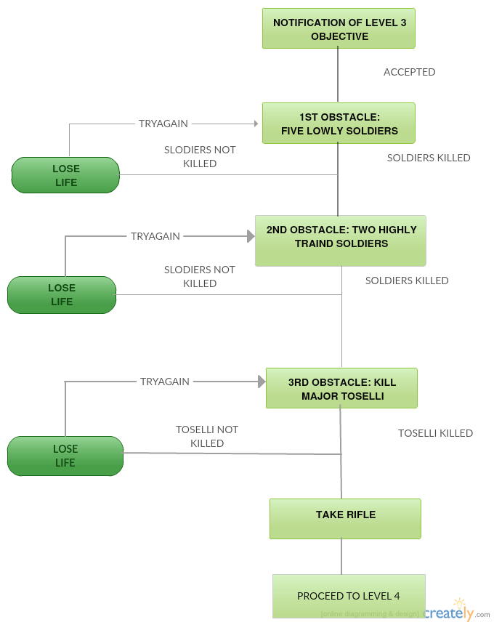

Figure : Level 3 Game Flow

**Level 4:**

Figure : Level 4 Game Flow

**Level 5:**

Figure : Level 5 Game Flow

**Level 6:**



Figure : Level 6 Game Flow

**Level 7:** Figure 13 Level 7 Game Flow

START

Go to armament store

Get out of Tent

Get weapon

Wait

Unlock

YES FAIL

Dinning camp

Change dress

Bombard

Camp-2

Attack

Attack

FAIL 🡪CHECKPOINT-1

PASS

FAIL 🡪 CHECKPOINT-2

PASS

PASS

FAIL 🡪CHECKPOINT-3

PASS

🡪CHECKPOINT-4 FAIL

SUCCESS

contaminate

MISSION ACCOMPLISHED

## 2.3 Game physics and statistics

**Level 1:**

The physics and statistics on this level are described as follows

1. Jogging: this is a basic action of jogging around the arena. This enables the player to get to the destination they want with small time; thus avoiding health deterioration due to bad weather.
2. Sprint: this action enables the player to sprint forward fast. This makes it even easier and convenient for the player to navigate around the map and find available resources (water in this level).
3. Crouching: in this level even though the player may not be required to crouch; it helps the player to pass through barriers when navigating the map.

**Level 2:**

The player move in a 2D side scrolling plane, either from left to right or vice versa.  
The player can jump either straight up and down or in a parabola going left or right.  
The player can cross paths with enemy characters unless it is hit by an attack, which pushes it back.  
The leaders’ character should be mostly impervious to attacks, except when they establish a weakness and present an opportunity for the player.  
 When an obstacle is in front of the player character it cannot proceed further in that direction.  
Gravity should be present.

**Level 3:**

The physics and statistics on this level are described as follows

* Jogging: this is a basic action of jogging around the arena. This enables the player to get to the destination they want with small time; thus avoiding health deterioration due to bad weather.
* Sprint: this action enables the player to sprint forward fast. This makes it even easier and convenient for the player to navigate around the map and find available resources (water in this level).
* Crouching: in this level even though the player may not be required to crouch; it helps the player to pass through barriers when navigating the map.
* Switch weapon: To switch between weapons.
* Fire: To attack enemy soldiers (swing sword, shoot shot gun or thrown spear)

**Level 4:**

**// game physics and statistic is missing**

**Level 5:**

The physics and statistics on this level are described as follows

1. Movement: this is a basic action of moving around the game.
2. Jogging: this is a basic action of jogging around the arena. This enables the player to attack fast and makes sure that the player doesn’t become an easy target.
3. Jumping: this is a basic movement to jump over obstacles.
4. Sprint: this action enables the player to sprint forward fast to attack or hide. This makes the player and even harder target.
5. Swing: This is an attacking mechanism when the player has a sword as a primary weapon
6. Throwing: This is an attacking mechanism when the player has a spear as a primary weapon
7. Shooting: This is also an attacking mechanism when the player has a shot gun as a primary weapon
8. Blocking/Defending: this is a defense mechanism of raising a shield. The character may raise its shield to defend itself. This reduces the impact of being hit by an enemy
9. Crouching: This is a hiding mechanism that may be helpful when sneaking behind enemy lines or when trying to dodge enemy bullets

**Level 6:**

Both level seven and six inherit the same game physics as level seven below.

**Level 7:**

**Running**

When running on Straight Street there will be smooth travel. When an obstacle is faced the player will need to the direction arrows to change his direction accordingly. Otherwise a collision with these stones will cause some vibration, loose of balance and failure. The player can use speed up and speed down mechanisms to achieve his goal.

**Jumping**

When the barrier is faced or there is hole the player will be capable of jumping up to 0.5meter.This enable to pass different obstacles faced on the way.

The 7th Level of Adwa will require that the game player takes a stealthy approach rather than an aggressive one. It will include stages that require the player to sneak past guards or sneak up behind them and execute a sneak attack. It will encourage the player to use weapons that do not make loud noises such as his spear or sword. If the player is spotted by nearby enemy soldiers they will alarm other nearby soldiers which will set a very hard challenge for the player.

# Architectural Design

## 3.1 Graphical representation and Description

**Level 1:**

SOUND

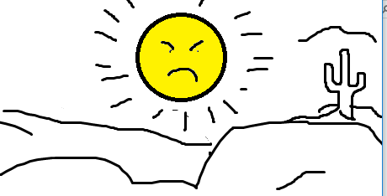

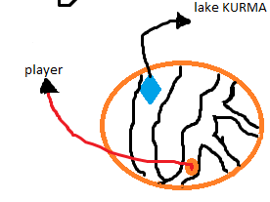 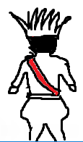

Figure 14: architectural design

**Description:**

**Environment**: the environment will look like a desert location since it is near Dalol (the lowest level on earth). The environment makes it hard for the player to survive unless there is a water to drink for the player.

**Player**: the player stars with a drained health condition. And he is exhausted with the harsh condition of the environment.

**Challenge**: the challenge in this level is not a human enemy, but a challenge of getting over the environmental challenges. The other challenge would be the challenge of getting to Bahtahagos which will be the end of the level.

**Sound** : some of the sound include crow sound in the desert, and wind or a thunder sound around the desert and the likes.

The sketch for the player, the challenge and the environment will look like the figure below:

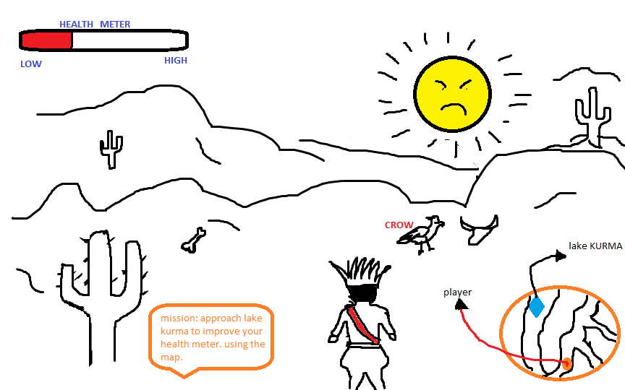

Figure 15: architectural view of level 1

**Level 2:**

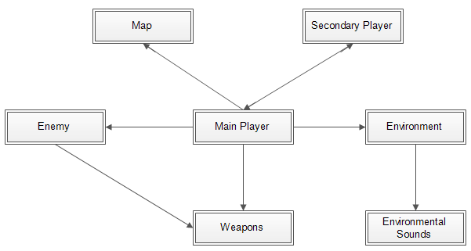

Figure 6: architectural view of level

* + **Description of Architecture Views**
  + **Main player**: is the main character in the game that is controlled by the user.
  + **Enemy**: are the opposing soldiers (Italian soldiers) in the game. They are activated only when the player is in a certain range from them. Then they come on to the player and start attacking.
  + **Weapons**: are objects like swords, spears, guns etc…
  + **Environment**: Are the locations and its surrounding for the level 2 action takes place. The location changes from scene to scene.

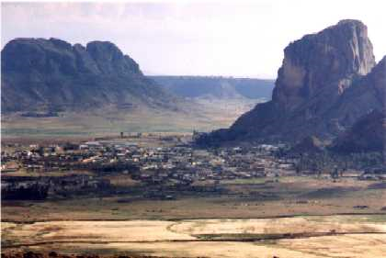

1. The overall area where the action takes place. This place will be a desert area where distant sound of gunfire and other war type sounds can be heard.
2. The road to Ras Mengesha: the player starts journey to Ras Mengesha’s Location (Senafe).
3. Senafe: The place where Ras Mengesha was held captive.
4. The road to safety: up on recuing Ras Mengesha the player guides him to safety.
5. The fight locations with the soldiers encountered: These places are fictional. (The fights did occur only that the places might not be accurate)

* **Environmental Sounds**: Is the different background sounds heard during game play. The different sounds are played in accordance of the player location and actions.

1. Since the whole environment is in a desert area, desert wind sounds are played throughout the level.
2. When the player is in action:
   1. When the player is fighting against the players.
   2. When the player is hit by a bullet or other weapon
   3. When the player strikes the enemy soldiers
   4. When the player swings or fires a weapon
3. When other objects are struck:
   1. When the player hits the soldiers with or without a weapon
   2. When the player hits non moving objects
4. When the player and he’s fellow soldiers communicate
   1. When they discuss strategies
   2. ሽለላ ሲያካሂዱ！
5. And other sounds:
   1. When the player walks, jog’s or jumps
   2. Sound effect

* **The secondary player:** the secondary player is the player that is designed to go where ever the main player goes. For this level Ras Mengesha is the secondary player.
* **Map**: provides information to the user where the players location is.

**Level 3:**

**Main Player** 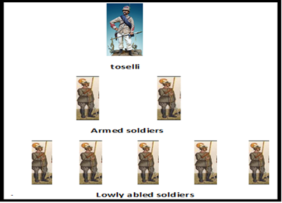

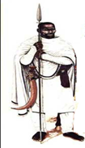 **Environment**

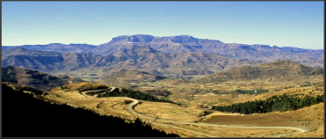

**Enemy**

**Enemies**

Weapons

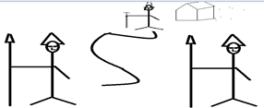

**Map**

Figure 17: architectural view of level 3

**Player**: an ordinary Ethiopian Patriot participating in the heroic act of war against the Colonialist army of Italy.

The main character or the player wears traditional Ethiopian clothes that our grand ancestors wear at a time of war.

The main character follows some hair style that shows an insight about the past .

The figure shows the above description of the main character.

**Enemies:** Since in this level there are five consecutive soldiers, two highly trained soldiers and Major Toselli on the enemy side.

Five Consecutive Soldiers: Each of them has the same characteristics like wearing cloth, strength or skill level, holding similar weapon.

The five soldiers wear military clothes that look like the past Italian army used.

This five soldiers located at some distance consecutively but somehow hidden area or not straight direct shown for the player or the main character.

**Two Highly Trained Soldiers:** This soldiers are somewhat the same as the five soldiers except they are not simply killed because of they are highly trained and so the player of the game have to throw the weapon fast to kill both of them and also the player faces with both of them in the game arena at the same time. They are standing straight up by holding their weapon to guard the Major Toselli

**Major Toselli:** Major Toselli is commander of the army so his graciousness makes him different from other soldiers

Major Toselli wears a military cloth but little different than other soldiers

Major Toselli wears also a military topper with a weapon (sword) on its hand

Major Toselli located on the tent guarded by the two highly trained soldiers

**Weapons:** In this level the player only allowed to use two weapons, sword and spear

This objects are traditional Ethiopian weapons used in the war and also in other situation so we try to make somehow similar used in our country

Player holds the weapon with right hand,

Player holds spear at the center with right hand up and sword at the edge which is all custom

**Environment**: since the battle is held on Ambaalagi, the landscape of the area is surrounded with mountain and few plants somehow like a desert so we try to create an environment not exactly the battle but relative to it.

In the environment there is a mountain with different and relative height located at some distance

There is a flat area between these mountains

Few Trees and shrubs are sparse in the environment

There is ambient /wind sound just like a desert as the player walk through the environment

Some small size stone included in the environment

In the environment there is also a tent where a Major Toselli located

**Map**: this object is interfaced with the main player that it can provide accurate information to the user. It gets the current location of the player and continuously updates throughout the game play.

**Narration Videos**

At this level the player have to be notified about the war and also the objective of the game to do so we designed narration videos including a text, background image and sound track.

The text tells the player about the war story

The background image gives some description about the location on which the battle is held

The sound track related the war story

The First Italo-Ethiopian War

On 7 December 1895, One of the three army of Menelik's commanded by the RasMengeshaYohannes went to the battle of AmbaAlagi to annihilate the Italians and kill the commander of Italian’s Army called Major Toselli.

Figure 18: an example of narration view

**Special Effects**

The player is not supposed to do any animations in this level.

The actions the player perform are to run, throw spear, and swing the sword

The ambient sound of the environment looks like a wind sound of the high temperature area

Since the player uses sword and spear so any distance ecplosion not heard in this level

The player can shout if killed by the enemies

The sound of the player shouting looks like a pain sound or groan

**Level 4:**

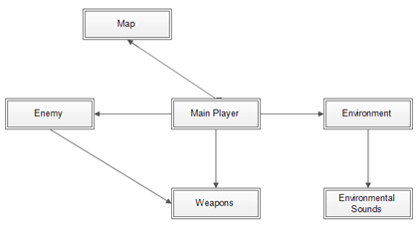

Figure 19: architectural view of level 4

* + **Main player**: is the main character in the game that is controlled by the user In this level the player will find themselves set up on a mountain with mountain artillery.
  + **Enemy**: are the opposing soldiers (Italian soldiers) in the game. They are activated only when the player is in a certain range from them. Then they come on to the player and start attacking.

The enemy's will be the brigade that is controlled by Albertone's.

Albertone's askaris brigade will attack in different set ups like they will come up, three or two groups.

Weapons: are objects guns, **the player will use Hotchkiss**

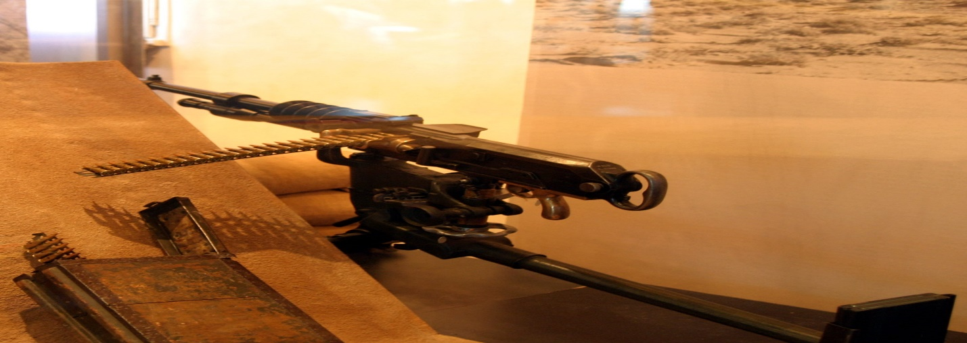

* + **Environment:** Are the location and its surrounding for the level 4 action takes place. The location changes from scene to scene.

There will be mountain in, which the Ethiopian's (Ras Alula's position)

one mountain for KidaneMeret, then, Italian brigades (Albertone's askari brigade) was the first to encounter the onrush of Ethiopians at 6:00, near KidaneMeret, where the Ethiopians had managed to set up their mountain artillery.

The fight locations with the soldiers encountered: These places are fictional. (The fights did occur only that the places might not be accurate), the overall terrain where the player operates

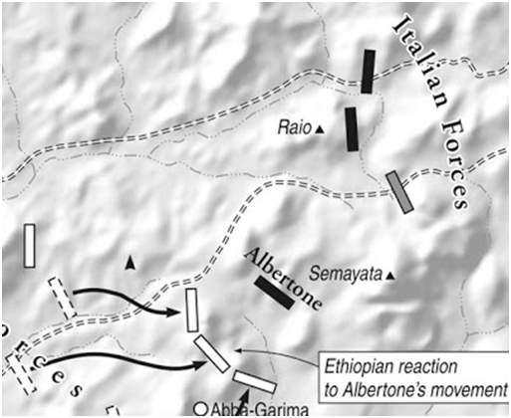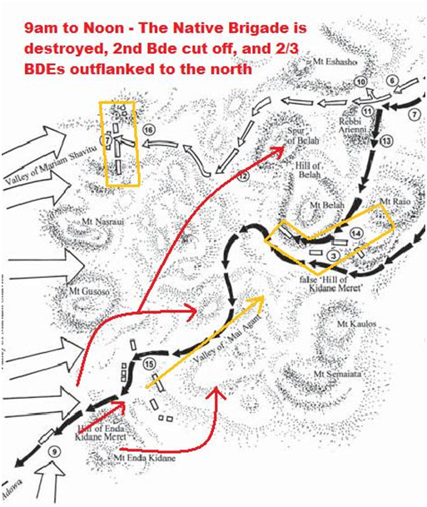

Figure 20: real map view of level 4

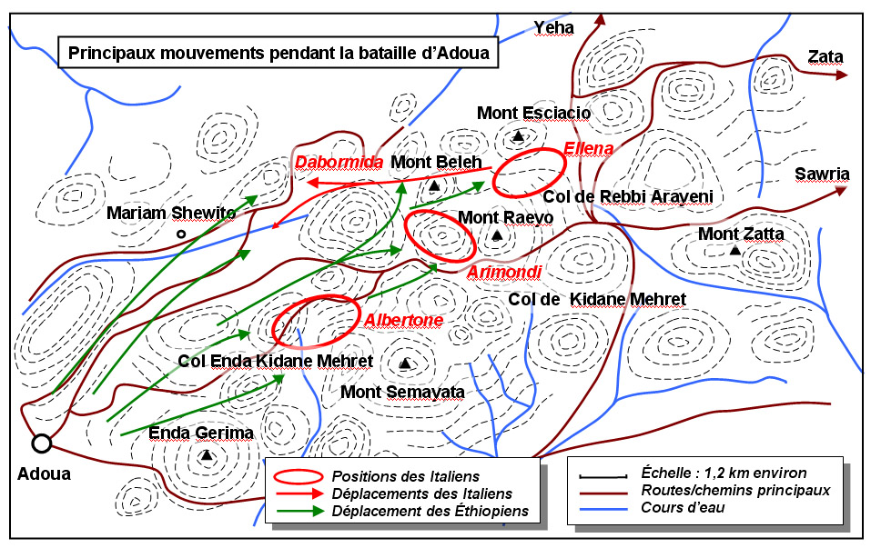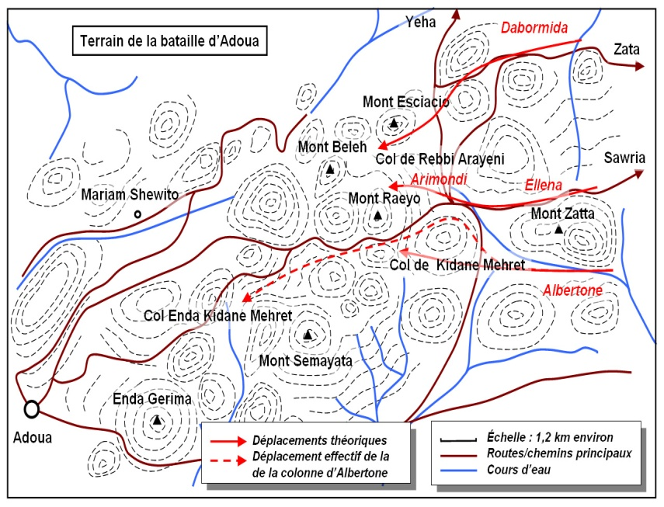

Figure 21: real map view of level 4

* + **Environmental Sounds**: - Is the different background sounds heard during game play. The different sounds are played in accordance of the player location and actions.

1. Since the whole environment is in a desert area, desert wind sounds are played throughout the level.
2. When the player is in action:
   1. When the player is against the players.
   2. When the player is hit by a bullet
   3. When the player fires the enemy soldiers
   4. When the player fires a weapon
3. When other objects are struck:
   1. When the player hits nonmoving objects
4. And other sounds:
   1. When the player walks, jog’s or jumps
   2. Sound effect
   * Map: provides information to the user where the players location is.

**Level 5:**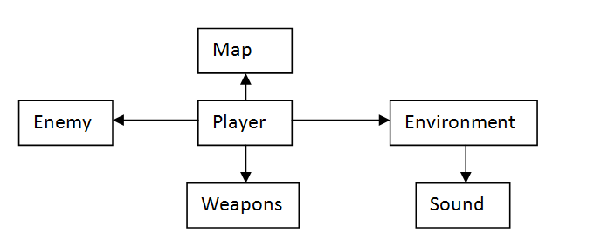

Figure 22: architectural view of level 5

The modules seen on the architectural view above is the representation of the different modules in this specific level. It describes each module separately and the relations between the modules.

* + - **The Map**: There are two 'maps' we are concerned about. One's the internal map that the game engine operates on and there's the external map which is the representation of this internal map on the player's screen. The internal map will be developed based on the terrain map shown on the next page. The external map that the player sees is shown at one corner of the screen and the mockup of it is also shown on the next page.

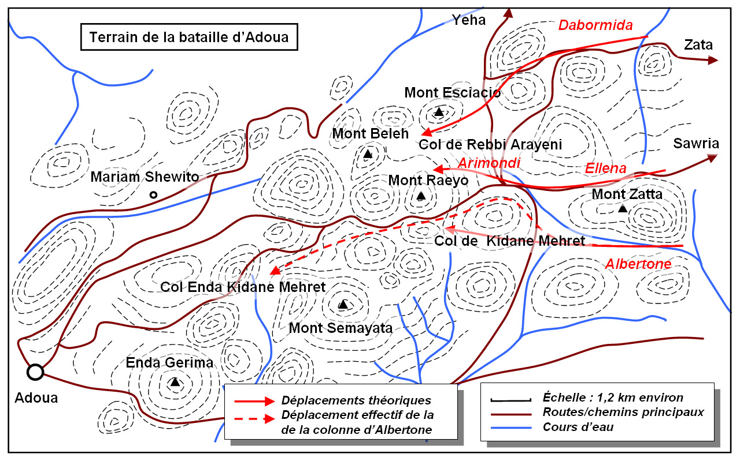



Fig 23: Internal map showing Ethiopian positions and Italian advances

* + - **Enemy:** The enemy soldiers are depicted in the game in a grey uniform with a bell shaped hat. They are depicted in the picture below.

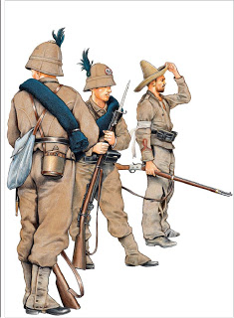

Fig 24: Italian soldiers

The enemy soldiers interact with the player individually. Their scripts are activated when player approaches them. This is shown in the picture on the next page.

* Player: depicted with a black star.
* Enemy soldiers: depicted in red arrows pointed in the player's direction.
* When R=D, soldiers get activated.
* When looking at an enemy, yell “Zeraf”.
* When shooting, activate rifle sound.

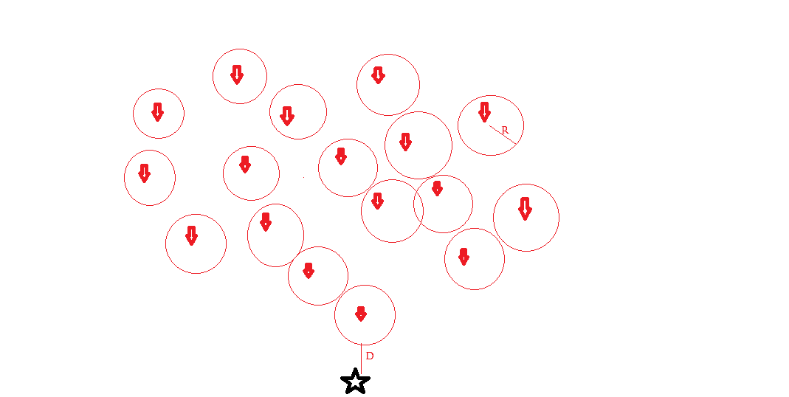

Fig 25: Interaction of player with enemy soldiers

* + **Environment**: The Environment that we assumed is just to look like the rural areas of ancient Ethiopia and also since Albertone's askari brigade was the first to encounter the onrush of Ethiopians at 6:00 we assumed the war to happen in the middle of the day where the sun is above the head.

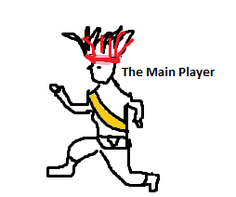

Figure 26:sketch for the main player

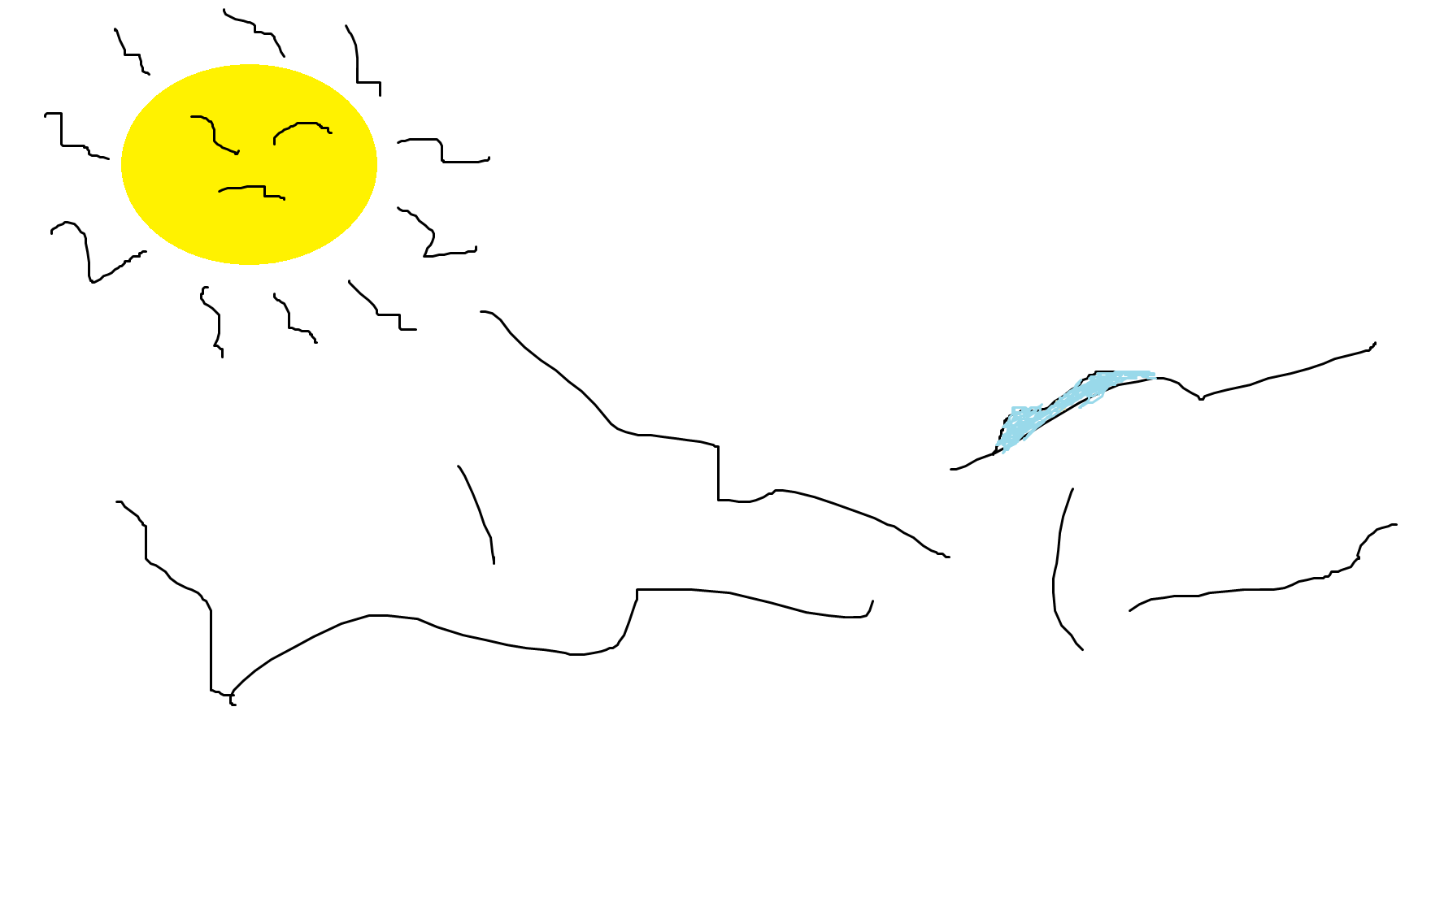

Fig 27. The environments of that time

* + The player of the game is ancient time Minilik soldier who have battled so many internal and external wars and also who is also someone with so much loss of power and strength but taking a final measurement in order to free himself and his country.
  + The enemies were soldiers with so much support and strength but lucking the courage and tactic to achieve the goal.

**Weapons**: The weapon being used in this level is a rifle and will be used against the soldiers as they approach. The weapons and their interaction with the player module is explained broadly in the detailed design section.

**Interaction between views**: We could see all the three views in the game but now we would see the component and connector view.

**Component and Connector view**:

**Components**: Computational elements, or elements that have active role in the system.

**Connectors**: Means of interaction between components.

Regarding this type of view our level has main components of the player and the enemy.

**Our enemy**

**Our Player**

Artillery

Figure 28:components

Our player uses supports he gets from his environment in order to survive and win the game.

The player follows the Albertone’s fleeing soldiers in order to reach the Arimondi’s brigade which he finally helps him achieve the aim of the game and finish.

Since the environment is mountain and the enemy forces don’t have any idea about the environment our player uses this advantage to enable him survive and get the support of Minilik’s soldiers which enables him finally swamp the area and kill Arimondi.

**Level 6:**

The architectural design for level six has seven modules. Environment, sound, enemy, weapons, map, player (main character), and fellow Warriors. The interaction between these modules is shown in the figure below.



**Figure 29: Module Relation Diagram**

The interaction between the different modules is clearly shown above using the Relations diagram. Below is a slightly detailed description of this modules.

1. **Weapons**

In this stage of the game (level 6) the fellow warriors and the player will use the following weapons for attack:

1. Spear
2. Shield

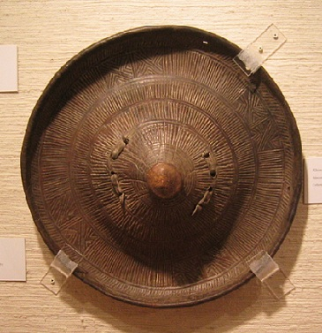

Figure 30: a sample picture of shield used by the Player

1. Shotel (A **shotel** is a curved sword originating in Abyssinia. The curve on the shotel's blade has an almost semi-circular shape. The blade is flat and double-edged with a diamond cross-section. The blade is about 40 inches (1,000 mm) in total length and the hilt is a simple wooden piece with no guard. The shotel was carried in a close fitting leather scabbard )

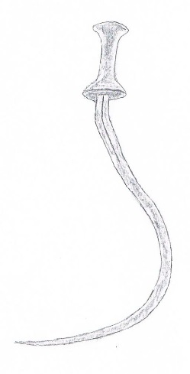

Figure 31: sketch of Shotel

1. **Sound**

The battle at this stage is fought between the Oromo cavalry and the player on one side and the Italian forces led by General Vittorio Daborimida. Due to the constraints discussed on the previous SRS document the player will not be on horseback. But in an effort not to overlook and diminish the Oromo cavalry’s role in the battle the following sound tracks will be added:

1. Horses charging
2. Horses jumping
3. Horses falling

In addition the following sounds are included

1. Sounds created by the use of the weapons
2. Sounds that reflect human conditions( absorbing pain, giving commands, running)
3. **Enemy**

The enemy of the player at level six is grouped in to two. The first enemy to be faced is a group of thirty soldiers in the Italian army. If the player is able to defeat this group of enemy he will advance to face General Vittorio Daborimida.

1. **Environment**

At the Start of the game the player and his fellow warriors will face their rival enemies (the Italians under command of General Vittorio Daborimida in a plane site view. But as the game starts to progress and the player has an upper hand the Italians will retreat in to a narrow valley where they will be cornered and are at disadvantage. Therefore the battle background is comprised of a plain field and a narrow valley.

The scenery of the environment will be a barren land with very little vegetation.

1. **Map**

The Map for this stage will show a plain field where the game starts and the place where the player advances if he is able to wound Gen. Vittorio Daborimida (the narrow Valley).

1. **Player** (main character)

The player will have the following weapons (spear, shotel with leather scabbard and shield), the player will be clothed in a fashion similar to the one shown in the picture below.

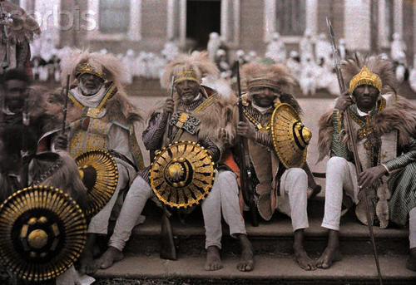

Figure 31: sample picture for clothing style of the player (main character)

1. **Fellow warriors**

For this level (level 6) the player is a ground soldier and fights on foot and its fellow warriors also are in foot. To show the overwhelming number of the Ethiopians over the Italians the fellow warriors will be greater in number, 40 soldiers. The numbers here doesn’t reflect the true ratio of fighters in both side of the story and are fictional. The fellow warriors will cloth in a similar manner as for the player (main character) described above. But for identification purpose the coloring of the clothes will be made different. Black clothes for the fellow warriors and white for the fictional main character (player).

**Level 7:**

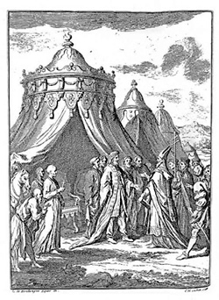The Ethiopian Kings The Italy soldiers

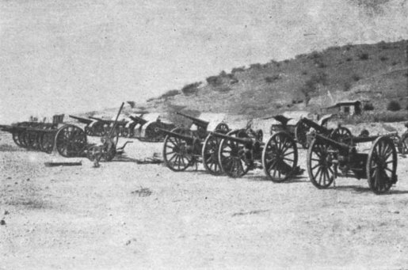

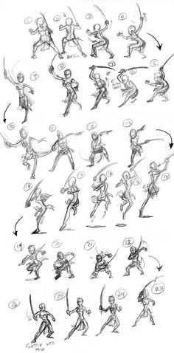 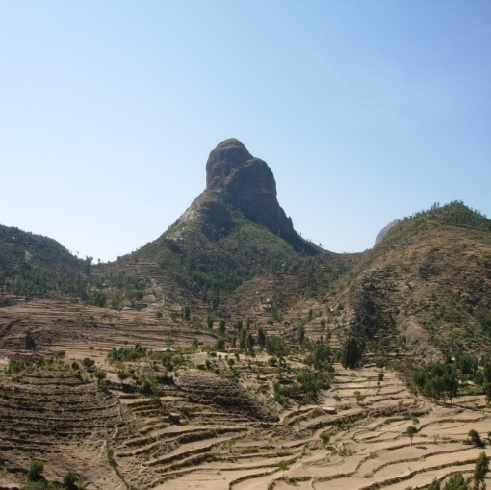

Figure 32: architectural view of level 7

The Ethiopian soldiers Mount Belah



Figure 34: The detail map of the war and the Ethiopian soldiers movement

## Interaction between views

**Level 1:**

This level contains two main game scenes, one is the Graphical User Interfaces (GUI) scene and another one is the game scene. The player could play on or off the background music, view the information of the controller and start or end this game on the GUI scene. The skybox, rigid body, players, Health Point Bars and Terrain will be applied to the game scene.

The game scene for this specific level contains different components in which all of them will be designed in order to recreate the scene of the situation that is the desert place.

1. **Terrain**

The terrain of this level will be developed with a desert condition indicating the harsh condition of the scene

1. **Skybox**

The main function of sky boxes is filling colorful to the sky space in the game. In this level the basic blue sky will be filled.

1. **Player**

The player is the main character in the game which will be controlled by the user in this level the player will find himself in an exhausted health status that is due to thrust.

**Level 2:**

In the previous section it’s discussed about the views of the architecture. Their interaction with each other is:

* **The main player**: is controlled by the user it will need an interaction from the other views. Rather it will activate and control the other views. For example when the player moves from place to place, the environment will change accordingly. The environment will change unless the player moves. The main player will act as resource for the other views when to be activated or changed. This main player is the controller for the other objects in the game. Its only when the player goes to the objects that the objects are activated and interacting.
* **Enemy**: is activated when the player gets close to him/her. The enemy then advances and attacks the main player. Then as shown in game mechanics, the enemy will go on and execute the tasks coded to it. Which are to check if it’s killed and deactivate, if not to keep advancing to the player and attack again. And the enemy can also pick weapons up and use them
* **Weapons**: are the objects in the game play. These objects do not act by themselves. They are accessories for the player and the soldiers. If they are dropped they are inactive unless the player or a soldier picks them up.
* **Environment**: as the player moves around in the map, the environment is continuously updated to ensure the user feels that the player is moving to the desired locations.
* **Environmental Sounds**: are called by the environmental view. As discussed previously when the player moves around and the environment is continuously updated, the sound s also updates to simulate the environment more accurately.
* **The secondary player**: this secondary player is first awakened when the main player finds the place where he is captive and frees him. Then he will follow the main player through all the battles to reach safety grounds. This is done by continuously updating the main player’s location and tracking him. And thus will require a continuous request for the location coordinates.
* **Map**: this object is interfaced with the main player that it can provide accurate information to the user. It gets the current location of the player and continuously updates throughout the game play. For this particular level, the player will use the map to go to Ras Mengesha’s location then to a safe ground which is the location of Ras Welle and Ras Mekonen.

**Level 4:**

In the previous section it’s discussed about the views of the architecture. Their interaction with each other is:

* + The main player: is controlled by the user it will need an interaction from the other views. Rather it will activate and control the other views. For example when the player moves from place to place, the environment will change accordingly. The environment will change unless the player moves. The main player will act as resource for the other views when to be activated or changed. This main player is the controller for the other objects in the game. Its only when the player goes to the objects that the objects are activated and interacting.
  + Enemy: is activated when the player gets close to him/her. The enemy then advances and attacks the main player. Then as shown in game mechanics, the enemy will go on and execute the tasks coded to it. Which are to check if it’s killed and deactivate, if not to keep advancing to the player and attack again.
  + Weapons: are the objects in the game play. These objects do not act by themselves. They are accessories for the player and the soldiers. If they are dropped, they are inactive unless the player or a soldier picks them up.
  + Environment: as the player moves around in the map, the environment is continuously updated to ensure the user feels that the player is moving to the desired locations.
  + Environmental Sounds: are called by the environmental view. As discussed previously when the player moves around and the environment is continuously updated, the sound's also updates to simulate the environment more accurately.
  + Map: this object is interfaced with the main player that it can provide accurate information to the user. It gets the current location of the player and continuously updates throughout the game play.

**Level 6:**

This level contains two main game scenes, one is the Graphical User Interfaces (GUI) scene and another one is the game scene. The player could play on or off the background music, view the information of the controller and start or end this game on the GUI scene. The skybox, rigid body, players, enemies, weapons, Health Point Bars and Terrain will be applied to the game scene.

The game scene for this specific level contains different components in which all of them will be designed in order to narrate the historic war between the Ethiopian Oromo Cavalry and the Italian’s Army lead by Daborimida at the battle of Adwa. These are:

**Terrain**: The terrain of this level will be developed with flora from grass, shrub and with low density of forest tree. Other game objects containing enemy objects and cube objects will be arranged on the terrain also. They constitute a completed game level together. Every game object obtains its own function in the game. This terrain will be designed to look like a narrow valley where the Oromo cavalry under Ras Mikael slaughtered Dabormida’s brigade.

**Skybox**: The main function of sky boxes is filling colorful to the sky space in the game. In this level the basic blue sky and white clouds will be filled.

**Player**: The player is the main character in the game which will be controlled by the user in this level the player will find himself in front of 30 Dabormida’s soldiers inside a narrow valley.

**Enemies**: For this level there will be 30 enemy soldiers and one enemy leader who is Daborimida . These players will be activated in random fashion when the player is in a certain range from them. Then they will come to the player and attack him.

**Weapons**: The main weapons which will be used for this level are:

* Sword
* Spear
* Shot gun

The player will have a permission to use any of these weapons but the enemies will have the permission to use only shot gun.

# HIGH LEVEL AND DETAILED DESIGN

## 4.1 LOGIC FUNCTIONS

**Common logic functions:**

**Player**

Most of the player’s script is implemented as an event triggered actions and this events are taken as key stroke from keyboard and what the player wants to do is given to the player with this functionality.

1. While (1)
2. **If** action from keyboard == “w”
3. Player moves forward;
4. else **If** action from keyboard == “s”
5. Player moves backward;
6. else **If** action from keyboard == “a”
7. Player moves left;
8. else **If** action from keyboard == “d”
9. Player moves right;
10. else **If** action from keyboard == “space”
11. Player jumps;
12. else **If** action from keyboard == “LShift”
13. Player advances faster in the direction the player is facing;
14. **If** action from keyboard == “c”
15. Player crouch irrespective of the direction faced;

**Environment**

Since the in environment holds every component in these game the duty of checking the position and activating enemies is given to it.

So it becomes

1. Check position change in player //first move of player (for the first time only)
2. Activate notification
3. Activate sound if available
4. Check if notification is destroyed
5. **If** destroyed save this point as last checkpoint.
6. **While (1)** // always do this as loop
7. Check the distance between enemies’ and the player
8. **If** in range activate enemies
9. Check the distance between player and sound source
10. **If** in range activate the sound source
11. Check the number of remaining enemies
12. **If** none
13. Display end of level notification
14. Terminate the level.

**Enemies**

1. **while (1)**
2. check player position
3. Approach player position
4. **If** in long range
5. Fire to the player // to the player position
6. **Else If** in short range
7. Perform combat action
8. **If** fired to self
9. Degrade health status
10. Destroy.

**Map**

1. While (1)
2. Fix map to the top right corner
3. Track player
4. Plot the player
5. Track the enemies
6. Plot enemies

**Life Status**

1. While1()
2. Set health status to 100%
3. If player gets hit
4. Reduce Health bar by certain percentage(Depending on the type of weapon)

**Unique Logic Functions**

**Level 1:**

Inherit all the common logic functions.

**@ Override Life Status**

1. While (player is in the environment)
2. Health decreases in proportion to time spent in the environment
3. While (player gets water)
4. Health increases in proportion water drunk by the player

**Level 2:**

Inherit all the common logic function and the next listed function.

**Secondary Player (Ras Mengesha)**

1. WHILE (1)
2. TRACK PLAYER POSTION
3. FOLLW THE PLAYER
4. ATTACK ENEMIES IN RANGE

**Level 3:**

Inherit all the common logic function

**@ Override Life Status**

1. While1()
2. Set health status to 100%
3. If player gets hit by ordinary soldier
4. Reduce Health bar by certain percentage(Depending on the type of weapon)
5. Else if player gets hit by Toselli or the two armed soldiers
6. Reduce Health by twice the normal percentage

**Level 4:**

Inherit all the common logic function and the next ones

**Albertone**

1. While(1)
2. run towards the player position
3. If in a reasonable range
4. Fire to the player
5. If fired to self
6. Degrade health status
7. If heath status reaches zero
8. die(Game over)
9. If(all the other enemies are dead && the player aims on self)
10. raise hand up(level passed)

**Level 5:**

Inherit all the common logic function

**Level 6:**

The only pseudo code that does not inherit from other levels is the restore health points. Which is given below:-

**Restore Health Points**

1. While(1)
2. If collided with the heal box
3. Increase the health points of the player
4. Destroy heal box

**Level 7:**

1. **Enemy Soldiers**
   1. Patrol

Each enemy soldier will patrol a give surrounding.

Pseudo Code

While the enemy soldier is not alerted

Wait a random amount of time at a given location

Move to a random choice of a given set of patrol locations

* 1. Spotting The character

Set a field of sight according to the position of the enemy soldier

If the character enters this field

Alarm nearby soldiers by making a noise

Start attacking the main character

* 1. Attack Only two at a time

If the Main Character is already in fight mode with two other soldiers.

Stay in an attacking position facing the character but never attack

If a message is received about the death of a solder that was in fight mode with the character

Attempt to get into fight mode with the character

Else wait for another message (loop)

* 1. Hearing sounds

If the enemy soldier hears a sound nearby, he will go to the origin of that sound

Pseudo Code

When the soldier hears a sound

Get the location of that sound

Move soldier to that origin

Play a soldier curious animation

* 1. Looking at Dead Enemy Soldiers

When the enemy sees a dead soldier, he will panic and alarm nearby soldiers

Pseudo Code

If a dead soldier gets within the field of sight of the enemy

Play a panic animation

Alarm nearby Soldiers

1. **Static Objects**
   1. Tents

Empty tents can hide the character from being seen by nearby soldiers

* 1. Camp Fires

The camp fires will incur a damage to any character who gets in contact with them

Pseudo Code

If a character (Player or soldier) collides with the fire object

Incur a damage at that character